<https://foodandnutrition.org/blogs/stone-soup/30-year-old-yeast-culture-can/>

**What a 30-Year-Old Yeast Culture Can Do**

[March 16, 2015](https://foodandnutrition.org/2015/03/) [Lauren Larson, MS, RDN](https://foodandnutrition.org/author/lauren-larson/)

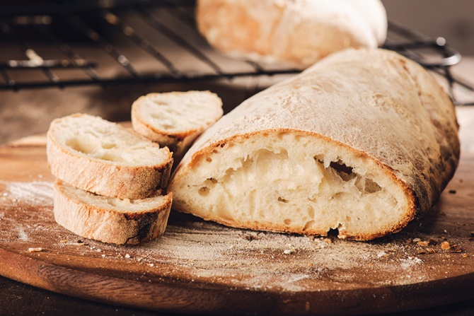

**It all started at a friend's Fourth of July barbecue** potluck. I planned to skip the bread basket, but after everyone couldn't stop raving about how delicious the bread was, I caved and grabbed a piece.

Turned out they were right, this bread was unlike anything I had ever had before. It had such a unique flavor and sweetness — sort of like a cross between corn bread, sweet bread and sandwich bread. As we all asked our friend who brought the bread for the recipe, he clued us in on the secret ingredient: a yeast culture that has been going since 1983. My first question was, "Wow, can I get some of that, so I can make bread this good?" And then I wondered, "How the heck do you keep a yeast culture alive for more than 30 years?"

Luckily our friend was willing to give me a bit of his yeast starter along with a little history lesson. The story of the 32-year-old yeast started in 1983 in Baton Rouge, Louisiana, in my friends' mother's cousin's neighbor's kitchen, with a regular old packet of Fleishman's yeast.

From there, the yeast culture was passed down from neighbor to cousin to my friend's mother. While plenty of young adults miss their mothers' cooking when they first move out, my friend missed his mom's bread so much he just couldn't quit it 'cold turkey.'" It didn't take him long to get a feeder starter from her, which he has continued to feed and make bread with regularly. Through the years he has kept the yeast culture alive through power outages and moves,  its taste evolving with different water supplies, air bacteria, temperature and numerous other conditions.

Now I'm the proud new owner of this yeast culture that started the year *Return of the Jedi* came out. After receiving a feeder starter and a few recipes to get me started, I began what has become an ongoing science project. I have been enjoying looking for different recipes, figuring out how to adapt them for a wet yeast, and baking bread (the fun part). I have experimented with all types of bread recipes, including no-knead Dutch oven bread, cinnamon rolls, pizza dough (the best!), waffles, hamburger rolls, ciabatta bread, dinner rolls and sandwich bread.

When I find a yeast bread recipe I want to try, I simply omit the dry yeast and substitute all or some portion of the liquid with the wet yeast starter. The greatest thing about a potato yeast starter is that it doesn't include any flour (as a sourdough starter would), so you can use any type of flour you want, presumably even gluten-free flours.

In my experimentation, I have found that the wet yeast starter requires more rising, or "proofing," time than recipes that use a dry active yeast packet call for. Even after months of experimentation I still under- or over-proof it sometimes, ultimately leading to either a dense or fragile loaf. The bread also tends to brown easier and faster with the wet yeast starter, requiring lower cooking temperatures and/or shorter cooking times.

Here are some instructions on starting a wet yeast yourself. Remember, it is a science experiment and depends heavily on the environment, so if it doesn't quite work out, keep trying and experimenting. If you end up with a "loaf fail," turn it into bread pudding, bread crumbs or croutons.

**First-Time Wet Yeast Starter**

*Recipe by Lauren Larson, MS, RDN*

**Ingredients**  
1 cup lukewarm water  
1/2 cup sugar  
1/4 cup instant potato flakes  
1 packet (2 1/4 teaspoon) dry yeast

**Directions**

1. Combine water, sugar, potato flakes and yeast in a small glass bowl. Cover loosely with plastic wrap and let stand at room temperature for two days to ferment.
2. Cover tightly and refrigerate.
3. Feed starter every 7-10 days to keep alive.

**Wet Yeast Starter Feeder**

*Recipe by Lauren Larson, MS, RDN*

**Ingredients  
​**1 recipe first-time or subsequent starter  
1 cup lukewarm water  
1/2 cup sugar  
1/4 cup instant potato flakes

**Directions**

1. Combine starter, water, sugar and potato flakes in a medium glass bowl. Cover loosely with plastic wrap and let stand at room temperature for 8-12 hours to double in size.
2. Divide mixture in half (about 12 ounces each), keeping one half as a feeder starter and the other half for baking (or to give to a friend).

**Basic Wet Yeast Bread**

*Recipe by Lauren Larson, MS, RDN*

**Ingredients**  
3 cups all-purpose or bread flour  
3 cups whole wheat flour  
1 tablespoon kosher salt  
1/4 cup sugar  
1/4 cups oil (use canola, grapeseed or vegetable)  
1 1/2 cups lukewarm water  
1 1/2 cups potato yeast starter

**Directions**

1. In a large non-reactive (glass or plastic) combine all ingredients with a non-reactive spoon. If desired, dough can be kneaded on a floured surface for 5-10 minutes, but it is not necessary. Cover loosely with plastic wrap and let sit at room temperature for 10-12 hours.
2. Lightly grease two 8"x4" bread pans with spray oil, set aside. Stir bread mixture down gently, divide in half, shape into loaves, and divide into two (8.5×4.5 or 9×5) greased loaf pans. Cover loosely with plastic wrap and let rise until top crests over the edge of the pans; 5-12 hours depending on the ambient temperature and the size of bread pan.
3. Preheat oven to 350ºF. Bake loaves for 35-40 minutes. Remove from oven when golden brown and a thermometer reads 190ºF when inserted into the center of the loaf (optional).
4. Allow loaves to cool for about 10 minutes in the loaf pan then invert pan to remove loaves. Transfer to a cooling rack to cool completely before serving.
5. Makes 2 loaves.

**Potato Yeast Waffles**

*Recipe by Lauren Larson, MS, RDN*

Here is a fun yeast waffle recipe to try. They are delicious topped with melted butter, warm maple syrup, nut butter, homemade applesauce, jam, and/or fresh fruit.

**Ingredients**  
3/4 cups milk  
6 tablespoons unsalted butter  
1 tablespoon honey  
1 cup all-purpose flour  
1 cup whole wheat flour  
1/2 teaspoon Kosher salt  
3/4 cup potato yeast starter at room temperature  
2 large eggs, lightly beaten  
2 teaspoon vanilla extract

**Directions**

1. Around 24 hours before preparing the waffles, heat milk, butter, and honey in a small saucepan over low-moderate heat until butter is melted. Set aside to cool to around 110ºF or until it feels lukewarm.
2. In a large non-reactive (glass or plastic) bowl, combine the flour and salt. Pour in the warm milk mixture and the potato yeast starter, and stir until just combined. Cover loosely with plastic wrap or a kitchen towel and set aside at a cool room temperature for about 12 hours.
3. In a small bowl, whisk together the eggs and vanilla extract. Whisk the egg mixture into the flour mixture and stir just until everything is just incorporated. Cover loosely with plastic wrap or a kitchen towel and transfer to the refrigerator for 12 hours or overnight.
4. Stir dough down gently before making waffles according to the instructions on your waffle maker.

**Cooking Note**

1. Serves 4 to 6.
2. You can substitute unsweetened applesauce for half of the butter to lower the fat and calorie content, but it will result in a much softer, less crispy waffle.

[**Lauren Larson, MS, RDN**](https://foodandnutrition.org/author/lauren-larson/)

**[](https://foodandnutrition.org/author/lauren-larson/)**

Lauren Larson, MS, RDN, CLC, is a clinical dietitian and certified lactation counselor based in Eagle, CO, and employed in Rifle, CO.